***How to connect android device chrome with pc chrome for inspecting element***

1. Connect the android device.
2. Open the chrome browser on your mobile.
3. Open terminal and check ***adb devices*** for real device connection.
4. Open chrome browser in your laptop and type: <chrome://inspect/#devices>
5. Type URL inside the url box and hit enter. You can see both your device will invoke the page. Then click on inspect to get the same page to your laptop.

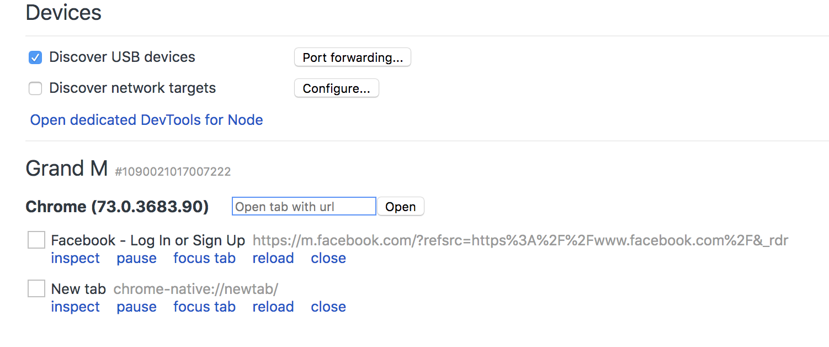

**The other way you can do this click**

*Chromeoptions -> more tools -> developer tools -> click on the connected device -> type url and click open -> Then click on the link below to get the same page to your laptop for inspecting mobile version element.*

